Supporting statement form
The supporting statement is your opportunity to tell us about your experience, your achievements and how you specifically suit the role you are applying for.
We want you to have the best chance of completing this section effectively, so please follow the guidance below.
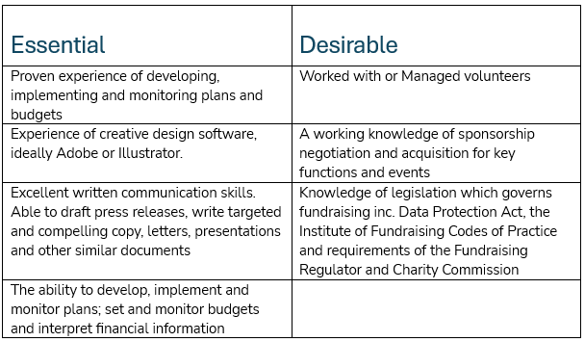
Within the Job Pack, you will see a table marked ‘Criteria’. This lists the experience and knowledge we are looking for (see example below).

The simplest and most efficient method to structure your supporting statement is to use each of the 'Essential' criteria as headers for sections of your statement. If you meet any of the 'Desirable' criteria, you can include those as well.
For each criterion, briefly explain how you fulfil that requirement, using examples where possible.
Additionally, consider concluding by sharing why the role and Pilgrims mission resonate with you. During the shortlisting process, the recruiting panel evaluates all applications based on these criteria, so ensure you address each one thoroughly.

Type your supporting statement in the box below. The box will expand as you type
No more than three pages please.

Having considered our CODE and the associated behaviours, please provide an example of how you demonstrate these in the box below. The box will expand as you type
No more than three pages please.

Eligibility to work in the UK
Do you require a certificate of sponsorship (Skilled Worker visa) to work in the UK?
Yes ☐ No ☐
Please note that proof of your eligibility to work in the country of employment will be checked if you are invited to interview. We are unable to sponsor anyone without Right to Work in the UK at this time. If you are unsure about your status, please contact hr@pilgrimshospices.org before applying.

References
Please note, we don’t ask you to provide your referee details at this stage, but will request them if you are offered the role.

Declaration
I confirm that the above information is completed and correct and that any untrue or misleading information will give Pilgrims the right to reject my application, to withdraw any employment contract offered or, if employed, to dismiss without notice.
Signed | type your name if you are completing electronically
Date

Data protection
Pilgrims complies with the provision of the Data Protection Act 1998 which defines the information provided on this form as sensitive data. By signing this form you give your consent for Pilgrims to process this, and other personal data, for the purposes of recruitment, selection and determining your suitability for the post. Any
data about you will be held in secure conditions, with access restricted to those who need it in connection with the application and selection process. Data may also be used for the purposes of monitoring the effectiveness of recruitment. In these circumstances all data will be kept anonymous.

